**AWS Well-Architected Tool**

The AWS Well-Architected Tool (AWS WA Tool) is a service provided by Amazon Web Services that helps users review and improve their cloud architectures based on AWS best practices. The tool is designed to help architects build secure, high-performing, resilient, and efficient infrastructure for their applications and workloads.

#### **Benefits:**

* **Improves cloud architecture** by identifying areas of improvement.
* **Aligns with AWS best practices.**
* **Automates architecture reviews.**
* **Provides actionable recommendations.**
* **Helps track improvements over time.**

**The five pillars of the AWS Well-Architected Framework:**

* **Operational Excellence-** Focuses on operations in the cloud, including monitoring, automation, and continual improvement.
* **Security-** Emphasizes protecting information, systems, and assets while delivering business value through risk assessments and mitigation strategies.
* **Reliability-** Ensures a workload performs its intended function correctly and consistently, including infrastructure recovery and failure management.
* **Performance Efficiency-** Involves using IT and computing resources efficiently to meet system requirements and to maintain efficiency as demand changes and technologies evolve.
* **Cost Optimization-** Focuses on avoiding unnecessary costs and ensuring you are achieving the maximum value from your cloud investment.

**Steps:**

**Step 1-** Search for "AWS Well-Architected Tool" in the AWS console.

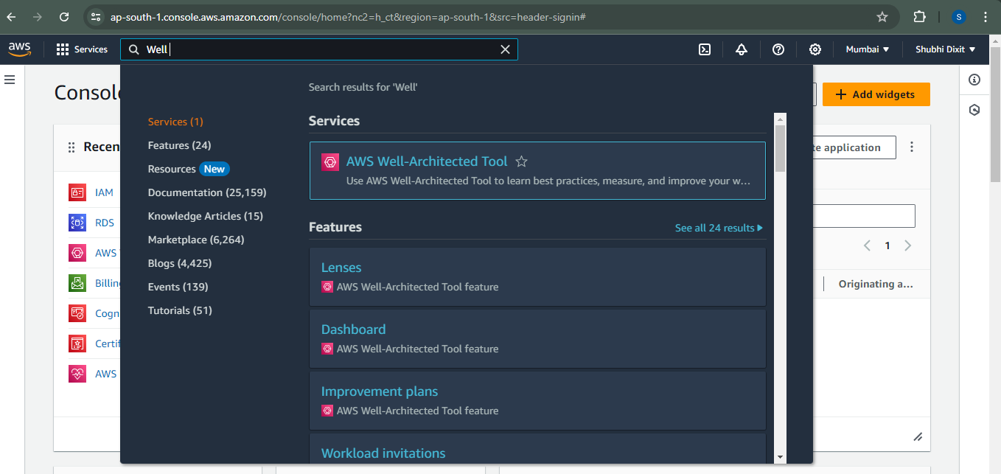

**Step 2-** Click on "Define workload" to start a new workload review.

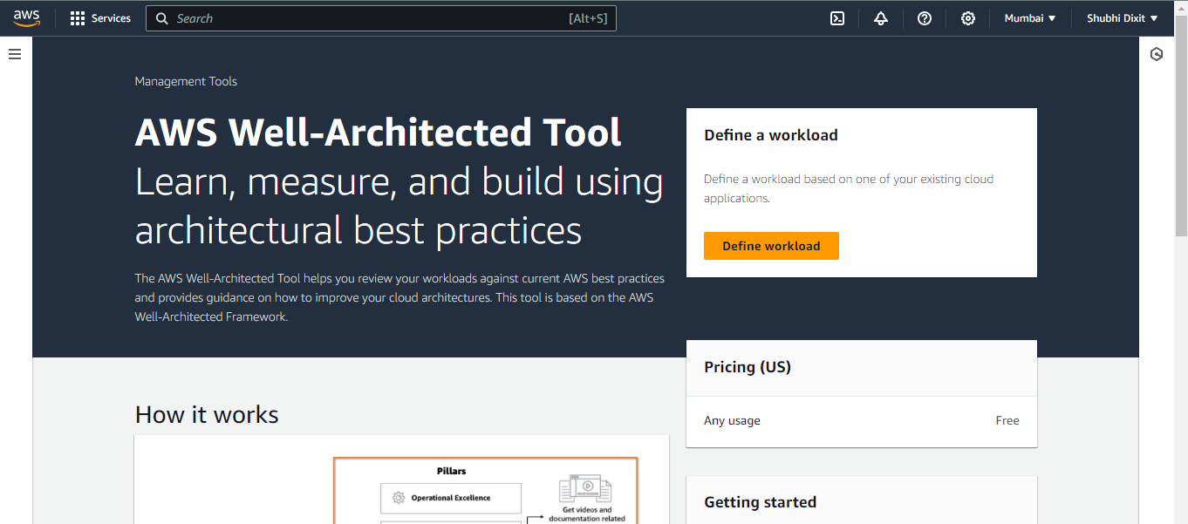

**Step 3-** Fill in workload details, including name, description, environment (production or pre-production), and other details.

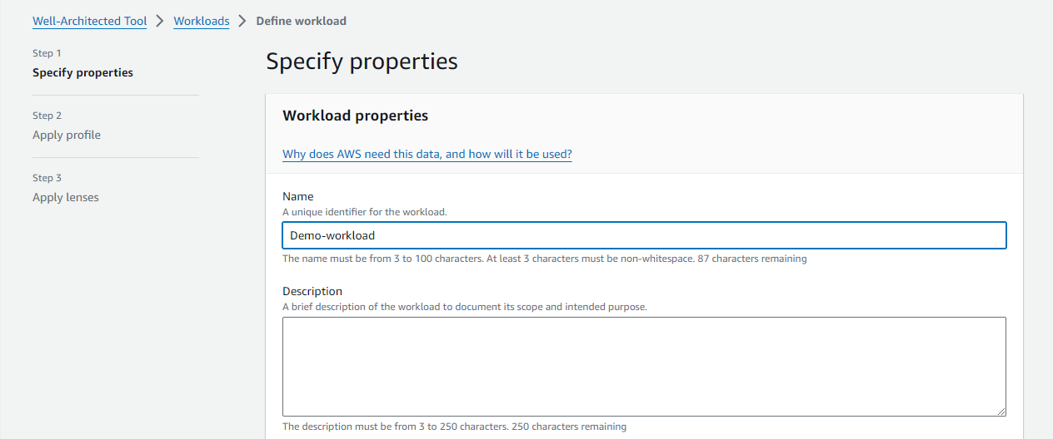

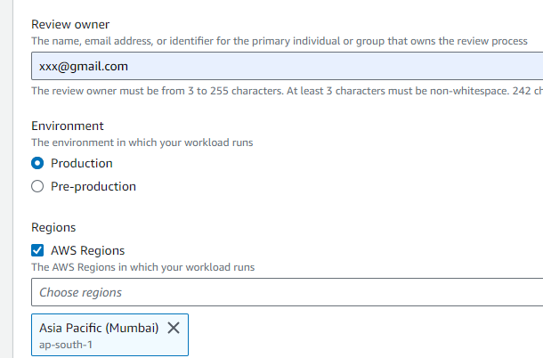

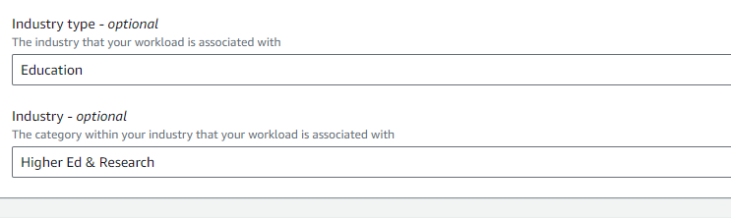

**Step 4-** The workload will be created successfully. Click on "Continue reviewing" to answer the questions.

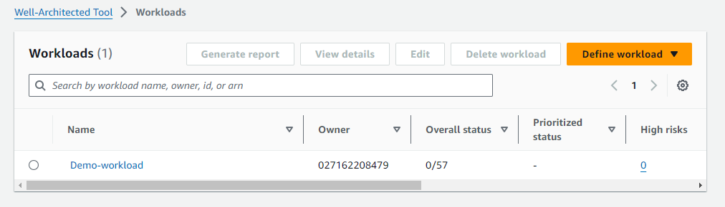

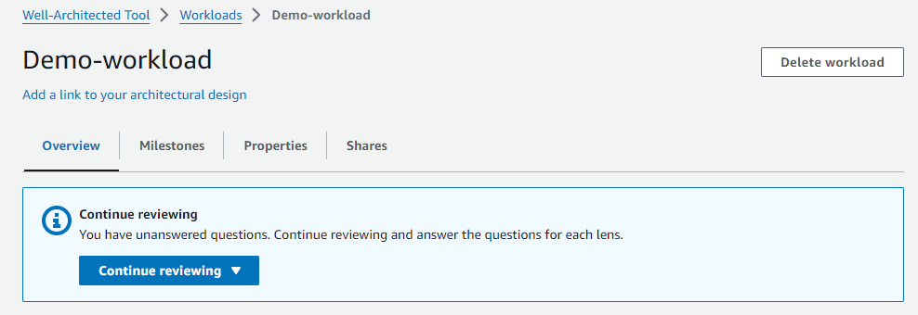

**Step 5-** The tool will present a series of questions categorized under the five pillars of the AWS Well-Architected Framework.

Answer these questions based on the current state of your architecture.

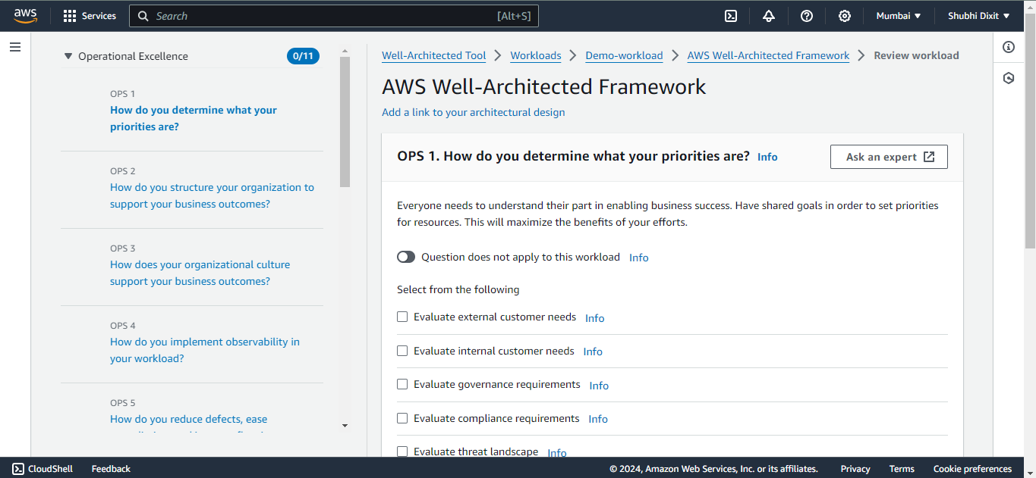

**Step 6-** After answering the questions, review the high and medium risk questions identified by the tool.

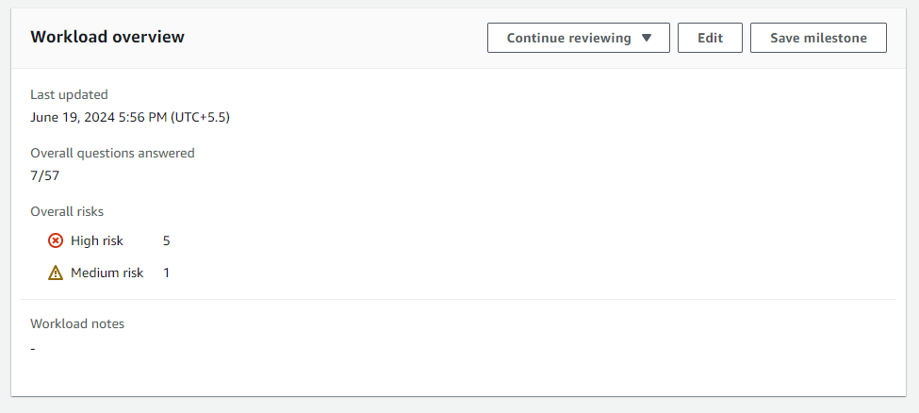

The tool provides detailed recommendations for each identified issue. These recommendations are aligned with AWS best practices and can help mitigate risks. Regularly repeat the review process to ensure ongoing compliance and optimization.

**Step 7-** The tool provides an overview of the number of questions answered in each category. This helps you track your progress and ensure all areas are covered.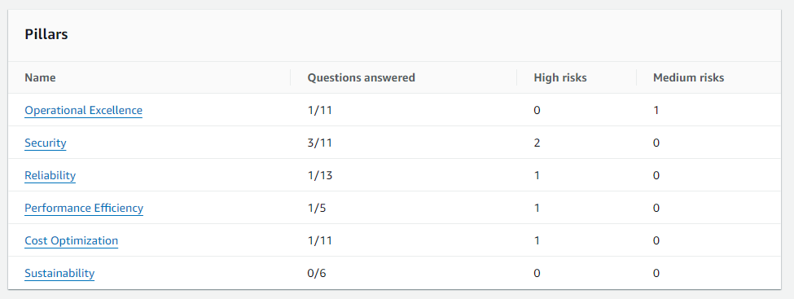

**Step 8-** After completing the review and implementing changes, download the report from the AWS Well-Architected Tool.

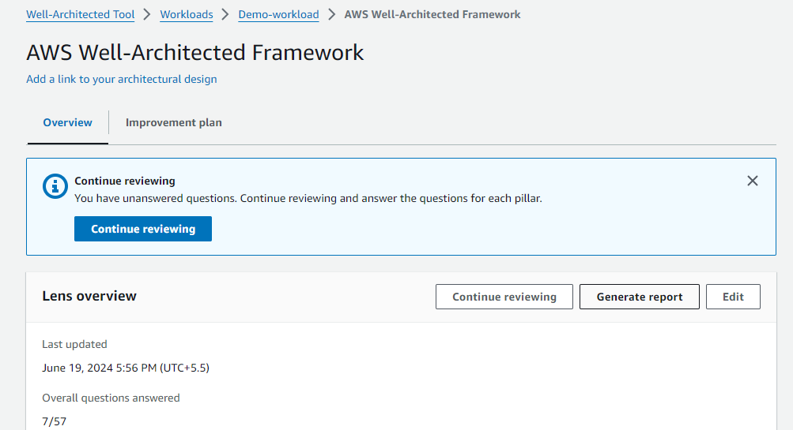

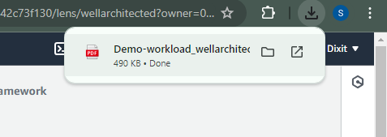

**NOTE-** The report provides a comprehensive overview of your workload, the identified risks, and the recommended improvements. It includes details on what was answered, what the right approach should be, and an improvement plan.

